Applied Machine Learning
Final-Term Complete Preparation Guide
Based on uploaded course slides, notes, assignments, PDF numerical guide, and notebooks
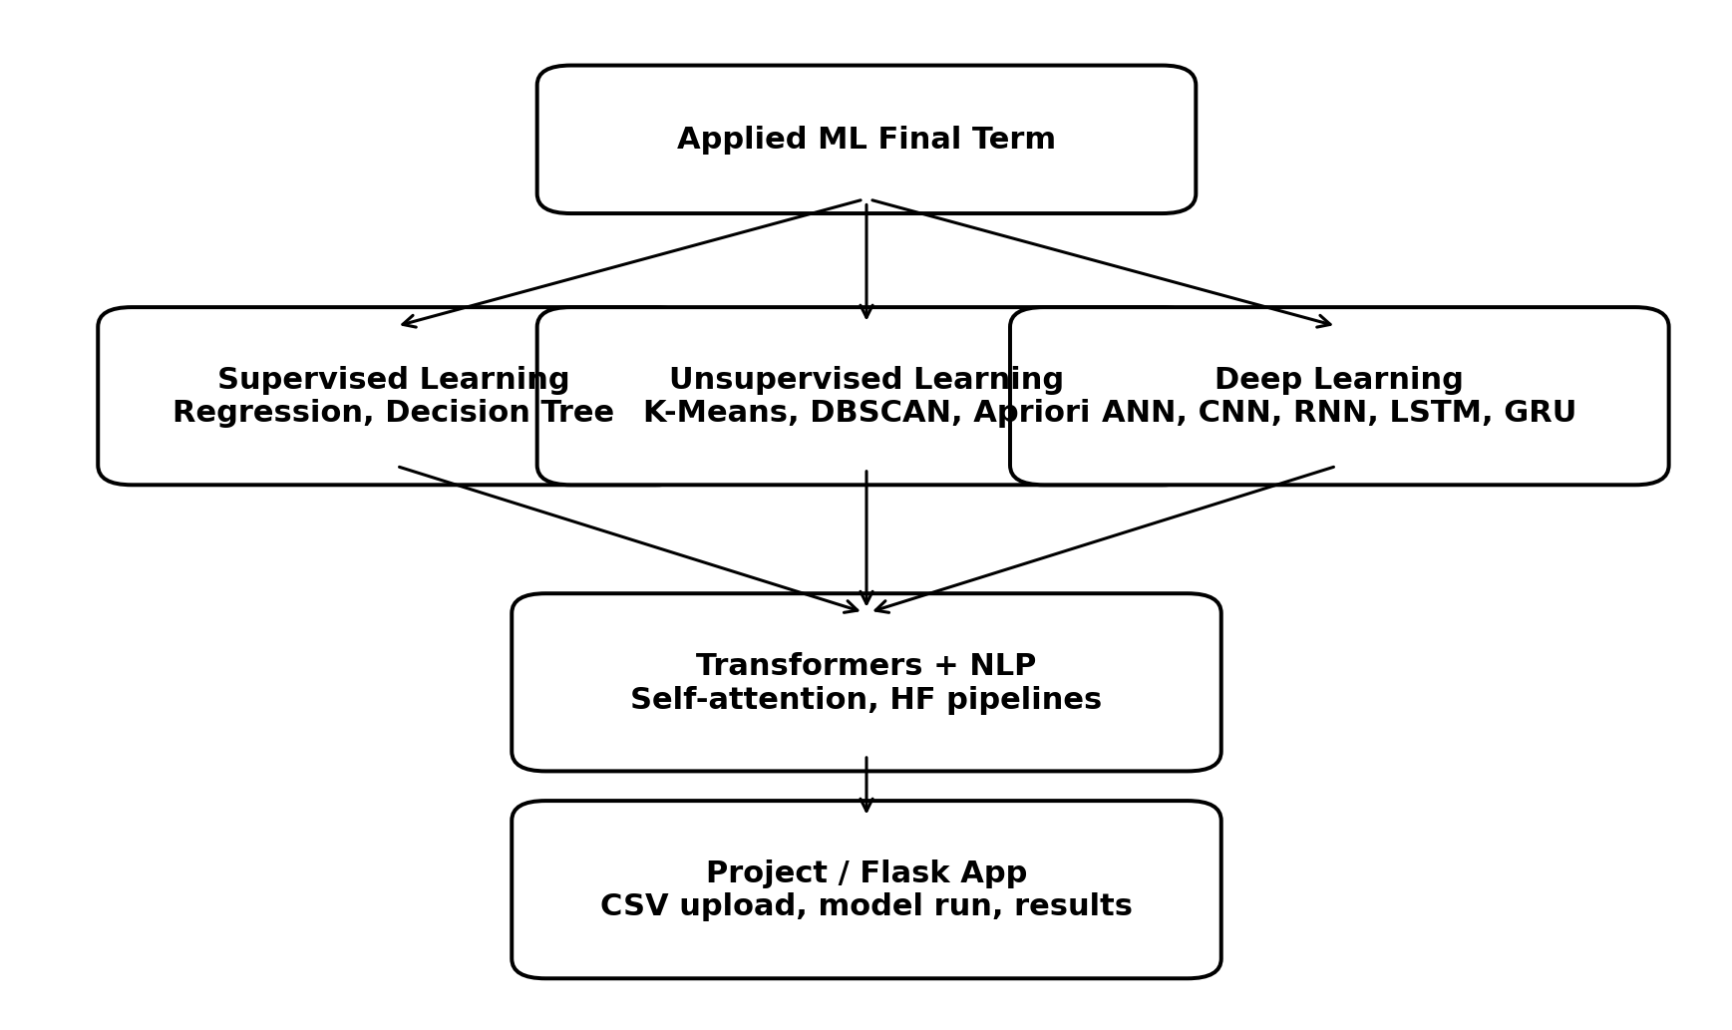
Figure: Complete syllabus map covered in this guide
Prepared for exam/viva style revision. Explanations are in easy Roman Urdu with English technical terms, examples, tricky questions, algorithms, and mock papers.
Important: Code examples are exam-friendly skeletons. For practical demo, paths/libraries must match your own system or Colab/Drive setup.

How to Use This Guide
- Pehle Chapter 1 ka big picture parho taa ke supervised, unsupervised aur deep learning ka map clear ho.
- Numerical chapters (Linear Regression, K-Means, DBSCAN, ID3, Apriori, Perceptron) ko formula + steps + example se revise karo.
- Code chapters mein imports, model building steps, compile/fit/evaluate sequence aur common errors yaad karo.
- Har topic ke end par tricky questions solve karo. Answers immediately diye gaye hain taa ke self-check ho sake.
- End mein 3 mock exams attempt karo: pehle answers na dekho, phir answer key se check karo.

Source Coverage Checklist
Uploaded material | Covered in guide
Linear Regression.pptx + What is Regression.docx | Regression types, simple/multiple formulas, solved numerical, tips
K-Means Algorithm.pptx + K_means.ipynb | K-Means theory, Euclidean distance, centroid update, code
DBSCAN.pptx + DBSCAN.ipynb | epsilon, minPts, core/border/noise, density reachability, code
Decision Trees.pptx | ID3, entropy, information gain, tree construction
A-priory Algorithm.pptx + A_Priory_Algorithm.ipynb | Market basket analysis, support/confidence/lift, mlxtend code
NN Lecture.pptx + ANN Numerical.pdf | ANN, perceptron, activation, OR numerical, XOR limitation
Deep Learning using Python.pptx + AML Notes.docx | Keras terms, Sequential, Dense, optimizer, loss, epochs, batch size
CNN.pptx + CNN_Image__Classification.ipynb | Convolution, pooling, flattening, image classification pipeline
RNN - LSTM - GRU.pptx + LSTM_GRU_Working_Example.ipynb | RNN, LSTM, GRU, text sequence code
Transformer.pptx + Transformers Codes.zip | Encoder-decoder, attention, embeddings, HF pipelines
Speech_to_Text.ipynb + Text_to_Speech.ipynb | STT and TTS code workflow
Assignment 3 and Assignment 4/Project | Flask CSV upload app, model services, pages, preparation tips

1. Big Picture: Applied Machine Learning Syllabus
Applied Machine Learning ka main goal yeh hota hai ke data se model ko learn karwaya jaye aur phir prediction, grouping, pattern discovery ya intelligent task perform karwaya jaye. Final-term material mein classical ML, clustering, association rules, deep learning aur transformers sab included hain.

1.1 Types of Learning
Type | Meaning | Your syllabus examples | Output
Supervised Learning | Data ke saath target/label hota hai. Model input se output predict karta hai. | Linear Regression, Decision Tree, Logistic Regression idea, ANN classification | Prediction/class label/value
Unsupervised Learning | Label nahi hota. Model khud pattern/group find karta hai. | K-Means, DBSCAN, Apriori | Clusters/frequent patterns
Deep Learning | Neural networks multiple layers ke through complex patterns learn karti hain. | ANN, CNN, RNN, LSTM, GRU, Transformers | Images/text/audio predictions

1.2 Exam Formula Sheet
Topic | Formula / key rule | Use
Linear Regression slope | b = (n sumXY - sumX sumY) / (n sumX2 - (sumX)^2) | Line ka slope find karna
Linear Regression intercept | a = (sumY - b sumX) / n | Line ka starting value/intercept
Euclidean Distance | d = sqrt((x2-x1)^2 + (y2-y1)^2) | K-Means/DBSCAN distance
K-Means centroid | new centroid = average of all points in cluster | Cluster center update
Entropy | H(S) = - sum p_i log2(p_i) | Decision tree impurity
Information Gain | IG = H(parent) - weighted entropy(children) | Best attribute select
Support | support(A) = count(A)/total transactions | Apriori item popularity
Confidence | conf(A->B) = support(A union B)/support(A) | Rule reliability
Lift | lift(A->B) = confidence(A->B)/support(B) | Association strength
Perceptron output | y = Step(w1x1 + w2x2 + b) | Binary decision
Perceptron update | wi = wi + a * xi * e | Wrong prediction ke baad weight update

1.3 General Exam Tips
- Definition + example zaroor likho. Sirf definition se marks kam mil sakte hain.
- Numerical mein formula, table values, substitution, final answer clearly show karo.
- Algorithm ke steps order mein likho: input, processing, stopping condition, output.
- Code question mein imports, data loading, model object, fit/predict/evaluate ka sequence yaad rakho.
- Tricky MCQs mein wording par focus: regression continuous value predict karta hai; classification class predict karti hai; clustering label ke baghair grouping karti hai.

2. Regression and Linear Regression
Regression supervised learning ka topic hai. Is mein target value continuous number hoti hai, jaise house price, salary, temperature ya marks. Classification mein output category hoti hai, lekin regression mein numeric output hota hai.

2.1 Regression Types
Type | Simple explanation | Example | Important note
Simple Linear Regression | One input X aur one output Y. Relationship line jaisi hoti hai. | House size -> house price | Equation: y = bx + a
Multiple Linear Regression | Multiple inputs X1, X2, X3 aur one numeric output. | Size, bedrooms, location score -> price | Equation: y = a + b1X1 + b2X2 + ...
Polynomial Regression | Curved relationship handle karta hai. | Growth trend, non-linear price curve | x^2, x^3 terms use hoti hain
Logistic Regression | Naam regression hai, lekin output classification probability hota hai. | Spam/not spam, yes/no | Binary output 0/1 ke liye use hota hai

2.2 Simple Linear Regression Formula
Equation: Y = B(X) + A. Y dependent variable hai, X independent variable hai, B slope/coefficient hai, A intercept hai. Coefficient ki value zyada ho to us feature ka impact generally zyada samjha jata hai.
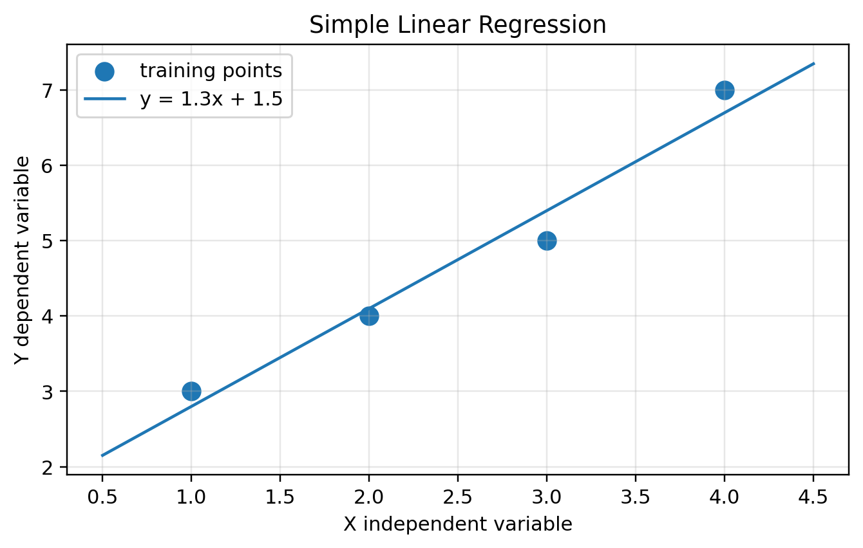
Figure: Regression line fitted on example points

2.3 Solved Numerical from Slides
X | Y | XY | X^2
1 | 3 | 3 | 1
2 | 4 | 8 | 4
3 | 5 | 15 | 9
4 | 7 | 28 | 16
sum=10 | sum=19 | sum=54 | sum=30
Step 1: n = 4, sumX = 10, sumY = 19, sumXY = 54, sumX2 = 30.
Step 2: B = (n sumXY - sumX sumY) / (n sumX2 - (sumX)^2) = (4*54 - 10*19) / (4*30 - 100) = 26/20 = 1.3.
Step 3: A = (sumY - B sumX) / n = (19 - 1.3*10) / 4 = 1.5.
Final equation: Y = 1.3X + 1.5. Agar X=5 ho to prediction Y = 1.3*5 + 1.5 = 8.0.

2.4 Algorithm: Linear Regression Numerical Solve Karne ka Easy Method
1. Table banao: X, Y, XY, X^2.
2. sumX, sumY, sumXY, sumX2 calculate karo.
3. Slope B formula apply karo.
4. Intercept A formula apply karo.
5. Final equation likho: Y = B(X) + A.
6. Prediction puchi ho to X ki value equation mein put karo.

2.5 Tricky Questions with Answers
Question | Answer
Logistic Regression regression hai ya classification? | Classification; binary classes ke liye probability output deti hai.
Multiple Linear Regression mein output kitne hote hain? | Normally one dependent numeric output. Inputs multiple ho sakte hain.
Coefficient ka sign negative ho to kya matlab? | Input increase hone se output decrease ho sakta hai.
Regression mein accuracy metric always best hai? | Nahi. Regression mein MAE/MSE/RMSE/R2 use hote hain; accuracy classification ke liye hoti hai.
Agar data curve mein ho to simple linear regression best hai? | Nahi, polynomial ya non-linear model better ho sakta hai.

2.6 Exam Tips
- Numerical mein final line equation zaroor box/clear likho.
- A aur B ko ulta mat likhna: slides mein Y = B(X) + A, A intercept hai, B slope.
- Dependent variable hamesha output/target hota hai. Independent variable input hota hai.

3. K-Means Clustering
K-Means unsupervised clustering algorithm hai jo similar data points ko groups mein divide karta hai. K ka matlab number of clusters hota hai. Yeh Euclidean distance use karta hai aur centroid ko repeatedly update karta hai.
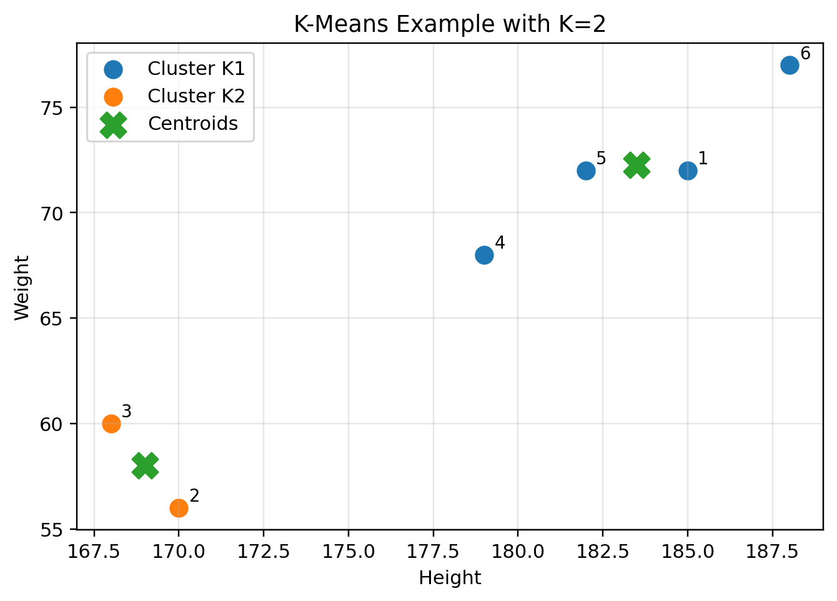
Figure: K-Means with height-weight data and centroids

3.1 Key Terms
Term | Meaning
K | Number of clusters. Agar K=2 hai to two groups banenge.
Centroid | Cluster ka center/average point.
Euclidean Distance | Two points ke darmiyan straight-line distance.
Iteration | Assign points -> update centroids ka one round.
Convergence | Jab centroids ya clusters change hona band kar dein.

3.2 Euclidean Distance
For two features Height and Weight: distance = sqrt((height2-height1)^2 + (weight2-weight1)^2). Jo centroid ka distance minimum ho, point us cluster mein chala jata hai.

3.3 Solved Example from Slides
Instance | Height | Weight
1 | 185 | 72
2 | 170 | 56
3 | 168 | 60
4 | 179 | 68
5 | 182 | 72
6 | 188 | 77
Initial centroids: K1 = Row 1 = (185,72), K2 = Row 2 = (170,56). Row 3 = (168,60).
Distance Row3 to K1 = sqrt((168-185)^2 + (60-72)^2) = sqrt(433) = 20.80.
Distance Row3 to K2 = sqrt((168-170)^2 + (60-56)^2) = sqrt(20) = 4.48. Minimum K2 hai, is liye Row3 K2 cluster mein jayegi.
K2 centroid update = average of (170,56) and (168,60) = (169,58). Final slide answer: K1 = {1,4,5,6}, K2 = {2,3}.

3.4 K-Means Algorithm
1. K choose karo.
2. K initial centroids select karo, randomly ya given rows se.
3. Har data point ka distance har centroid se calculate karo.
4. Point ko nearest centroid wale cluster mein assign karo.
5. Har cluster ka centroid average se update karo.
6. Steps 3-5 repeat karo jab tak clusters stable na ho jayein.

3.5 Python Code Skeleton

from sklearn.cluster import KMeans
import pandas as pd
import matplotlib.pyplot as plt

dataset = pd.read_csv('Kmeans.csv')
model = KMeans(n_clusters=2, random_state=42)
y_pred = model.fit_predict(dataset[['Height', 'Weight']])
dataset['cluster'] = y_pred
print(model.cluster_centers_)
print(dataset)
plt.scatter(dataset.Height, dataset.Weight, c=dataset.cluster)
plt.show()

3.6 Tricky Questions with Answers
Question | Answer
K-Means supervised hai ya unsupervised? | Unsupervised, kyunki labels given nahi hote.
K-Means arbitrary shape clusters ke liye best hai? | Nahi, DBSCAN arbitrary shapes better handle kar sakta hai.
Centroid ka formula kya hai? | Cluster ke points ka average for each feature.
Initial centroid change se result change ho sakta hai? | Haan, is liye random_state/n_init important hota hai.
Feature scaling zaroori hai? | Aksar haan, kyunki distance-based algorithm hai.

3.7 Exam Tips
- K-Means numerical mein distance table clean banao.
- Minimum distance ko circle/mark karo.
- Centroid update mein height aur weight dono ka average alag alag lo.
- Stopping condition likhna na bhoolo.

4. DBSCAN Clustering
DBSCAN ka full form Density-Based Spatial Clustering of Applications with Noise hai. Yeh density ke basis par clusters banata hai. K-Means ki tarah K pehle se dena zaroori nahi hota, lekin epsilon aur minPts dene hote hain.
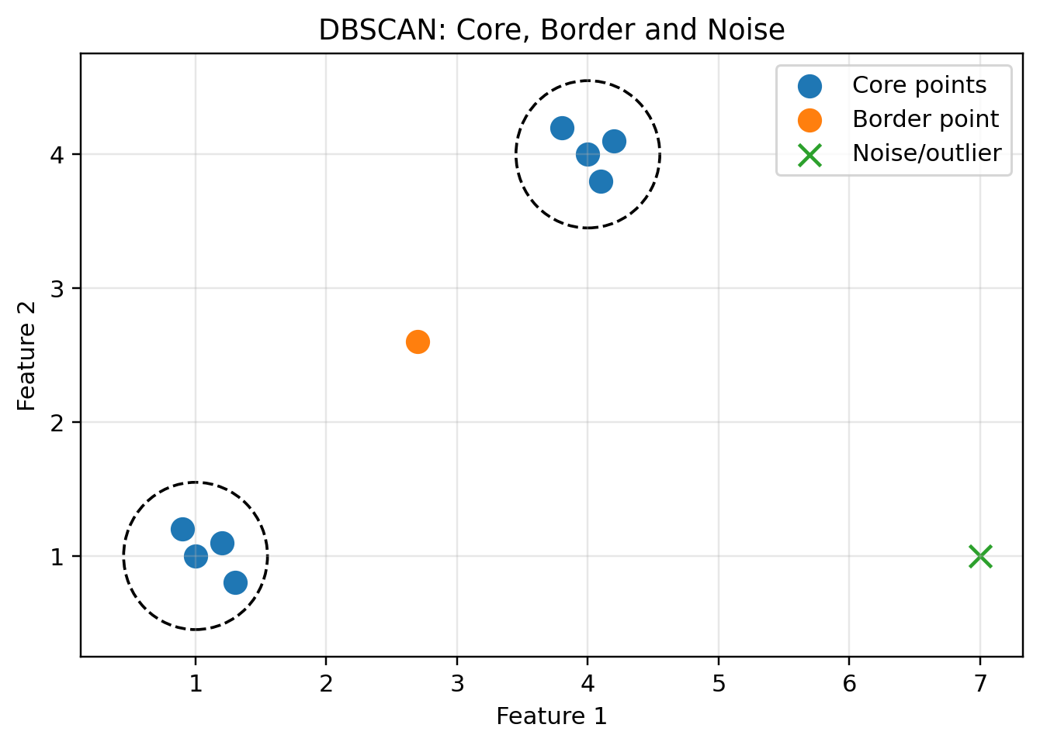
Figure: DBSCAN point types

4.1 Inputs and Point Types
Concept | Explanation
epsilon (eps) | Radius. Is circle ke andar neighbors count kiye jate hain.
minPts | Minimum points needed to make a dense region. Central point ko bhi count karte hain.
Core Point | Aisa point jis ke eps-radius ke andar at least minPts points hon.
Border/Boundary Point | Core nahi hota lekin kisi core point ke eps-neighborhood mein hota hai.
Noise/Outlier | Na core, na border. Cluster ka part nahi hota.

4.2 Density Reachability
Point P directly density reachable from Q tab hota hai jab P, Q ka neighbor ho aur Q core point ho. Agar core points ek dusre ke neighbor hon to clusters merge ho sakte hain. Noise points ko ignore kiya jata hai.

4.3 DBSCAN Algorithm
1. epsilon aur minPts set karo.
2. Har point ke eps-neighborhood mein points count karo.
3. Core, border aur noise identify karo.
4. Connected core points ko same cluster mein merge karo.
5. Border points ko nearest/reachable core cluster mein attach karo.
6. Noise points final clusters mein include nahi hote.

4.4 Python Code Skeleton

from sklearn.cluster import DBSCAN
import numpy as np
import matplotlib.pyplot as plt

data = np.array([[14,62], [16,35], [16,32], [17,32],
[44,66], [33,22], [12,67], [13,43],
[45,23], [32,32], [34,43], [15,31]])
model = DBSCAN(eps=10, min_samples=2)
labels = model.fit_predict(data)
print(labels) # -1 means noise/outlier
plt.scatter(data[:,0], data[:,1], c=labels)
plt.show()

4.5 DBSCAN vs K-Means
Point | K-Means | DBSCAN
Input | K clusters required | epsilon and minPts required
Cluster shape | Mostly spherical/round | Arbitrary shapes possible
Outliers | Sensitive to outliers | Can detect noise/outliers
Centroid | Uses centroid | No centroid needed
Scaling | Important | Important

4.6 Tricky Questions with Answers
Question | Answer
Central point ko minPts count mein include karte hain? | Haan, slides ke according central point bhi count hota hai.
DBSCAN mein K specify karna hota hai? | Nahi. Clusters density se automatically bante hain.
Label -1 ka matlab sklearn DBSCAN mein kya hota hai? | Noise/outlier.
Agar epsilon bohat chhota ho to kya hoga? | Zyada points noise ban sakte hain.
Agar epsilon bohat bara ho to kya hoga? | Alag clusters merge ho sakte hain.

4.7 Exam Tips
- Core point banane ke liye neighbor count + minPts condition yaad rakho.
- Border point core nahi hota, lekin core ke circle ke andar hota hai.
- Noise ko outlier bhi kehte hain; DBSCAN outlier detection ke liye useful hai.

5. Decision Tree and ID3 Algorithm
Decision Tree classification algorithm hai. ID3 greedy approach follow karta hai: har step par aisa attribute choose karta hai jiska Information Gain maximum ho ya entropy reduction best ho.
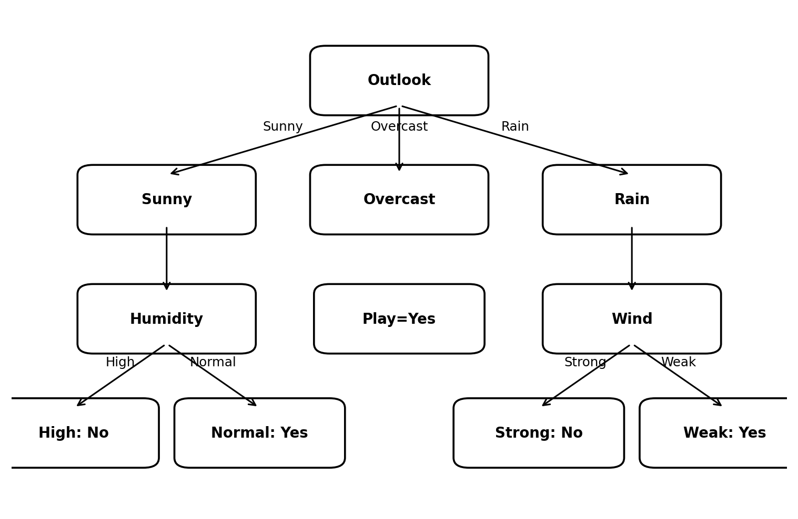
Figure: ID3 decision tree example using Outlook as root

5.1 Key Terms
Term | Meaning
Root Node | Tree ka first decision attribute. Maximum information gain wala attribute root ban sakta hai.
Internal Node | Further decision attribute.
Leaf Node | Final class label, e.g., Yes/No.
Entropy | Impurity/uncertainty measure. Zero means pure.
Information Gain | Parent entropy minus weighted child entropy. Zyada IG best.

5.2 Entropy Formula
Entropy: H(S) = -p(Yes)log2(p(Yes)) - p(No)log2(p(No)). Agar classes mixed hon to entropy high hoti hai. Agar all Yes ya all No hon to entropy 0 hoti hai.
log2(n) = log10(n) / log10(2). Agar calculator mein log base 2 na ho to yeh formula use karo.

5.3 Information Gain Formula
IG(S, Attribute) = H(S) - sum((Sv/S) * H(Sv)). Matlab parent entropy se children ki weighted entropy subtract karo. Maximum IG wala attribute select hota hai.

5.4 Mini Example: Play Tennis Style
Suppose total 14 examples: 9 Yes, 5 No. Parent entropy = -9/14 log2(9/14) - 5/14 log2(5/14) = 0.940 approx.
Attribute | Information Gain approx | Decision
Outlook | 0.246 | Highest -> root node
Humidity | 0.151 | May be used under Sunny branch
Wind | 0.048 | May be used under Rain branch
Temperature | 0.029 | Lower gain

5.5 ID3 Algorithm
1. Dataset ka parent entropy calculate karo.
2. Har attribute ke values ke liye child entropy calculate karo.
3. Weighted average child entropy nikalo.
4. Information Gain calculate karo.
5. Maximum IG attribute ko node/root banao.
6. Us attribute ke branches par remaining data split karo.
7. Repeat until leaf pure ho jaye ya attributes finish ho jayein.

5.6 Tricky Questions with Answers
Question | Answer
ID3 root kaise choose karta hai? | Maximum Information Gain se.
Entropy 0 ka matlab? | Pure node; saare examples same class.
Greedy approach ka matlab? | Har step par locally best attribute choose karta hai.
Decision tree overfit kar sakta hai? | Haan, bohat deep tree overfit kar sakta hai. Pruning help karti hai.
Minimum entropy aur maximum IG mein relation? | Jo split entropy zyada reduce karega, uska IG zyada hoga.

5.7 Exam Tips
- Entropy table banate waqt Yes/No counts clearly likho.
- Weighted entropy mein each branch ka fraction multiply karna na bhoolo.
- Root node choose karne ke baad remaining dataset par same process repeat hota hai.

6. Apriori Algorithm and Association Rule Mining
Apriori association rule mining algorithm hai. Isay Market Basket Analysis bhi kehte hain. Example: agar customer bread aur milk leta hai to diaper ya beer lene ka chance kya hai? Algorithm frequent itemsets find karta hai aur phir strong association rules banata hai.
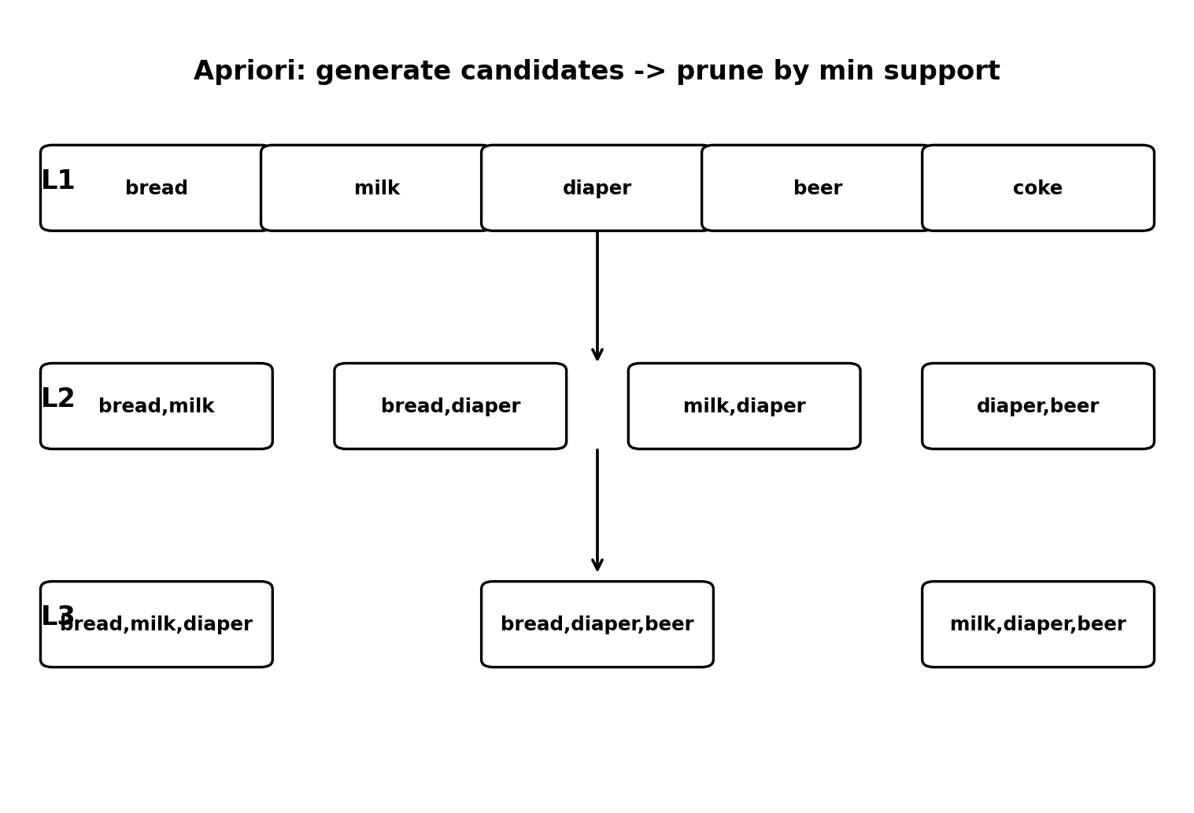
Figure: Apriori candidate generation and pruning

6.1 Important Terms
Term | Formula / meaning | Example
Transaction | One basket/order. | T1 = {bread, milk}
Itemset | Items ka set. | {bread, milk}
Support Count | Itemset kitni transactions mein aaya. | bread count = 4
Support | count/total transactions. | bread support = 4/5 = 0.8
Confidence | support(A union B)/support(A). | diaper -> beer = 0.6/0.8 = 0.75
Lift | confidence/support(B). | 1 se zyada means positive association

6.2 Dataset from Uploaded Material
TID | Items
T1 | bread, milk
T2 | bread, diaper, beer, eggs
T3 | milk, diaper, beer, coke
T4 | bread, milk, diaper, beer
T5 | bread, milk, diaper, coke
Minimum support count = 2 means itemset at least 2 transactions mein hona chahiye. Minimum support = 2/5 = 0.4.

6.3 Frequent Itemsets Example
Itemset | Support count | Support | Frequent?
{bread} | 4 | 0.8 | Yes
{milk} | 4 | 0.8 | Yes
{diaper} | 4 | 0.8 | Yes
{beer} | 3 | 0.6 | Yes
{coke} | 2 | 0.4 | Yes
{eggs} | 1 | 0.2 | No
{diaper, beer} | 3 | 0.6 | Yes
{bread, milk} | 3 | 0.6 | Yes
{milk, coke} | 2 | 0.4 | Yes
{bread, coke} | 1 | 0.2 | No

6.4 Rule Example
Rule: diaper -> beer. support(diaper union beer) = 3/5 = 0.6. support(diaper) = 4/5 = 0.8. confidence = 0.6/0.8 = 0.75. Agar min confidence 0.7 ho to yeh strong rule hai. support(beer)=3/5=0.6; lift=0.75/0.6=1.25, so positive association.

6.5 Apriori Algorithm Steps
1. Transactions ko one-hot/boolean format mein encode karo.
2. L1 frequent 1-itemsets support se find karo.
3. Candidate 2-itemsets generate karo.
4. Jo min support se kam hon unko prune karo.
5. Frequent k-itemsets se k+1 candidates generate karo.
6. Repeat until new frequent itemsets na milen.
7. Frequent itemsets se association rules banao using confidence/lift.

6.6 Python Code from Notes - Clean Version

import pandas as pd
from mlxtend.frequent_patterns import apriori, association_rules

data = [
['bread','milk'],
['bread','diaper','beer','eggs'],
['milk','diaper','beer','coke'],
['bread','milk','diaper','beer'],
['bread','milk','diaper','coke']
]
items = sorted({item for trans in data for item in trans})
encoded = pd.DataFrame([{item: (item in trans) for item in items} for trans in data])
frequent_itemsets = apriori(encoded, min_support=0.4, use_colnames=True)
rules = association_rules(frequent_itemsets, metric='confidence', min_threshold=0.7)
print(frequent_itemsets)
print(rules[['antecedents','consequents','support','confidence','lift']])

6.7 Tricky Questions with Answers
Question | Answer
Minimum support count 2 and total 5 ho to min_support value? | 2/5 = 0.4.
High confidence always useful association prove karti hai? | Nahi. Lift bhi check karo; lift 1 ke kareeb ho to weak relation ho sakta hai.
Apriori supervised hai? | Nahi. It is unsupervised association rule mining.
Eggs frequent kyun nahi? | Support count 1 hai, min count 2 se kam.
Apriori principle kya kehta hai? | Agar itemset frequent nahi, to uske supersets bhi frequent nahi ho sakte.

6.8 Exam Tips
- Support count aur support fraction confuse mat karo.
- Rule A->B mein confidence ka denominator A hota hai, A union B nahi.
- Lift > 1 positive association, lift = 1 independent, lift < 1 negative association.

7. Artificial Neural Networks and Perceptron
ANN biological neurons se inspired computing system hai. Model examples se learn karta hai aur task-specific hard-coded rules ki zaroorat kam hoti hai. Perceptron ANN ka simplest neuron hai jo binary classification karta hai.
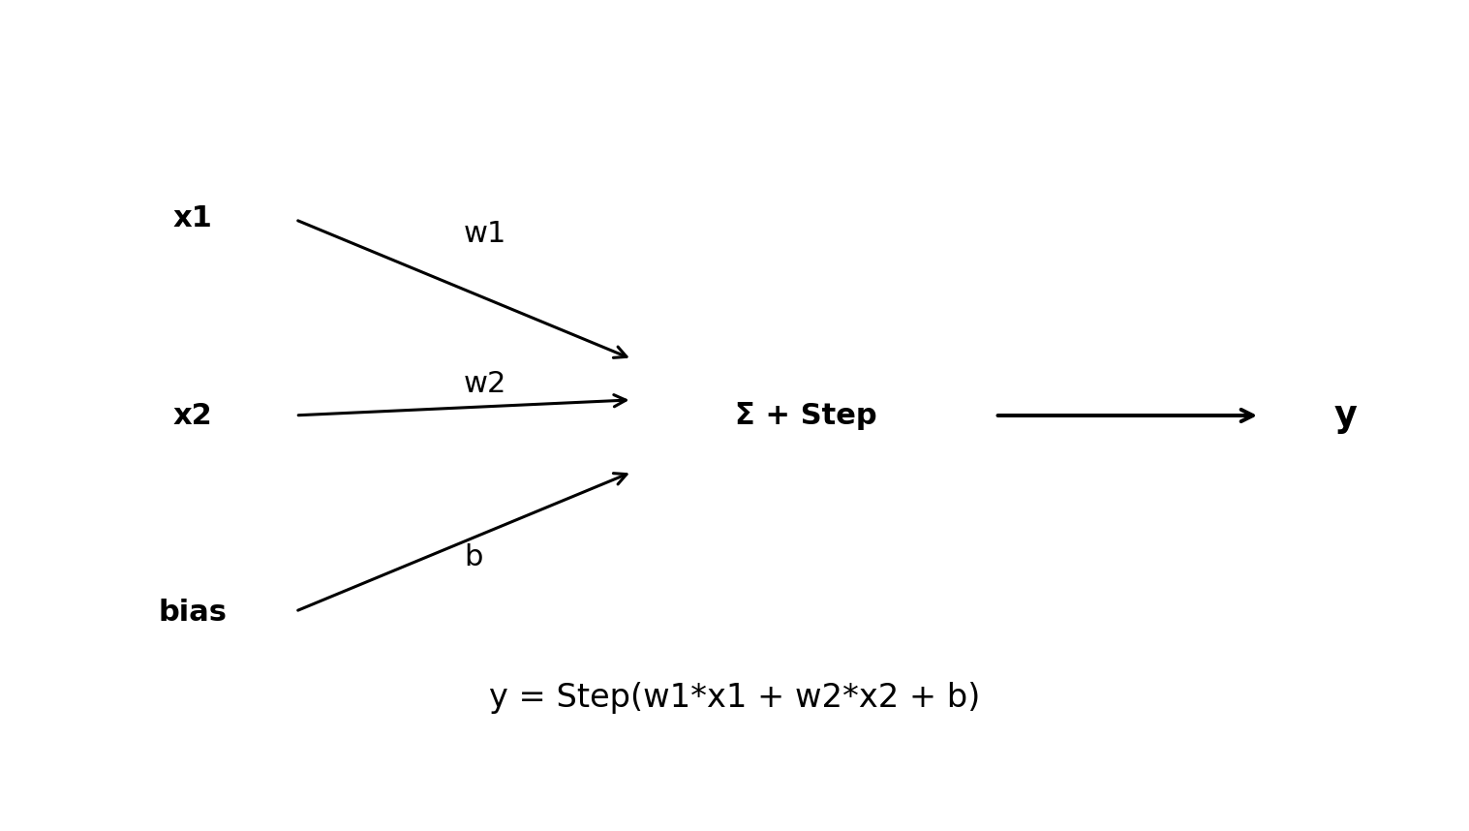
Figure: Perceptron input-weight-sum-output flow

7.1 Perceptron Basics
Symbol | Meaning
x1, x2 | Input features
w1, w2 | Weights
b | Bias
a | Learning rate
e | Error = expected - actual
y | Predicted output
Main formula: y = Step(w1*x1 + w2*x2 + b). Step function agar weighted sum threshold se zyada/equal ho to output 1, warna 0 de sakti hai.

7.2 Learning Process
1. Initially weights random values se start hote hain, e.g., -0.5 to +0.5.
2. Training data input do aur output calculate karo.
3. Expected output se compare karo.
4. Error e = expected - actual nikaalo.
5. Agar error zero nahi hai to weight update formula apply karo.
6. Pura dataset one time pass ho to one epoch kehte hain.
7. Epochs repeat karo jab tak errors zero/stable na ho jayein.

7.3 OR Function Numerical
x1 | x2 | Expected output
0 | 0 | 0
0 | 1 | 1
1 | 0 | 1
1 | 1 | 1
Initial values: w1=-0.2, w2=0.4, learning rate a=0.2. Bias ignored in this slide example.
Step 1: x1=0, x2=0 -> weighted sum = 0 -> output correct 0, no update.
Step 2: x1=0, x2=1 -> weighted sum = 0.4 -> output 1, correct, no update.
Step 3: x1=1, x2=0 -> weighted sum = -0.2 -> output 0 but expected 1. Error = 1 - 0 = 1.
Update: w1 = -0.2 + (0.2*1*1) = 0. w2 = 0.4 + (0.2*0*1) = 0.4. New weights: w1=0, w2=0.4.

7.4 XOR Limitation
Single perceptron sirf linearly separable functions learn kar sakta hai, jaise AND/OR. XOR non-linearly separable hai, kyunki points ko single straight line se separate nahi kar sakte. XOR solve karne ke liye Multi-Layer Perceptron (hidden layer) chahiye.
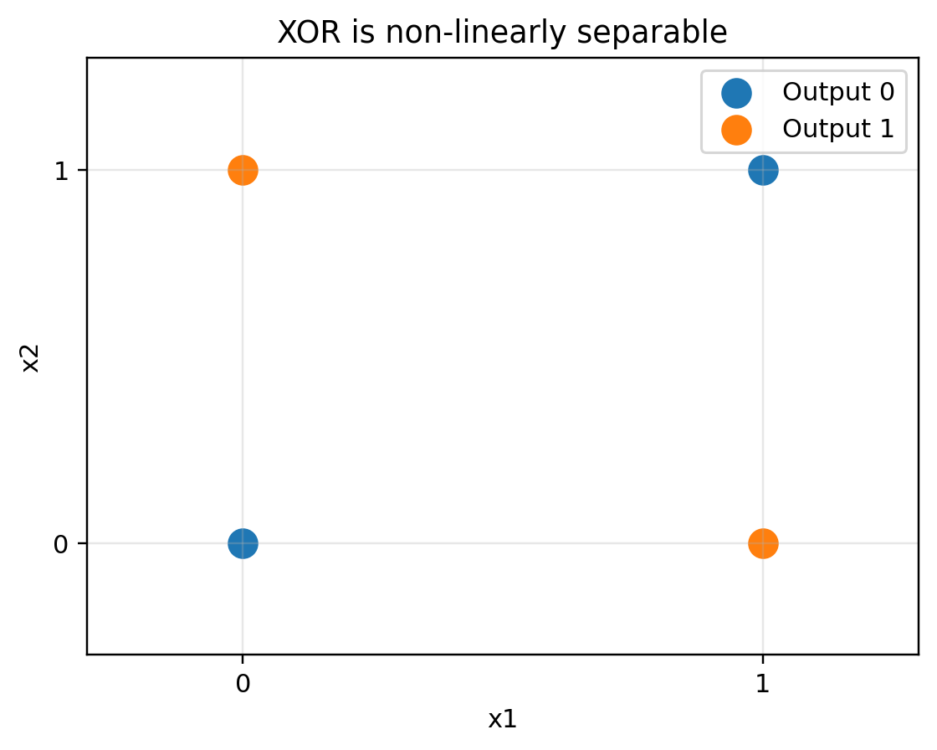
Figure: XOR pattern cannot be separated by one straight line

7.5 Activation Functions
Activation | Formula/Idea | Use
Step | threshold based 0/1 | Perceptron binary output
Sigmoid | 1/(1+e^-x), output 0 to 1 | Binary classification output
Tanh | output -1 to +1 | Hidden layers in older RNNs
ReLU | max(0,x) | Hidden layers; fast and common
Softmax | probabilities sum to 1 | Multi-class classification output

7.6 Tricky Questions with Answers
Question | Answer
Perceptron XOR kyun solve nahi karta? | XOR non-linearly separable hai; single straight decision boundary fail hoti hai.
Epoch kya hota hai? | Entire training dataset ka one complete pass.
Learning rate zyada ho to kya issue? | Model overshoot/unstable ho sakta hai.
Error formula kya hai? | Expected output - actual output.
Weight update kab hota hai? | Jab prediction wrong ho/error non-zero ho.

7.7 Exam Tips
- Numerical mein expected, actual, error clear likho.
- Weight update mein jis input xi ki value 0 ho, uska weight change nahi hota.
- XOR limitation ka diagram ya reason zaroor likho.

8. Deep Learning Using Python and Keras
Deep learning neural networks ka use karke complex data patterns learn karta hai. Keras/TensorFlow mein model banana mostly fixed pipeline follow karta hai: data load, preprocess, split, model build, compile, train, evaluate, save/load.
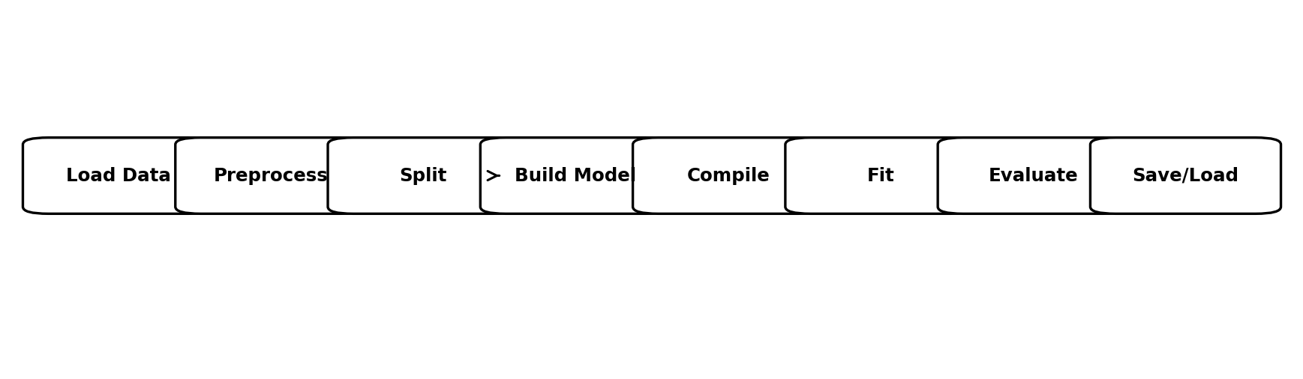
Figure: Keras model development pipeline

8.1 Keras Key Terms
Term | Meaning | Exam line
Sequential | Linear stack of layers | Layer by layer model banta hai.
Dense | Fully connected layer | Har neuron previous layer ke all neurons se connected.
Activation | Non-linearity introduce karta hai | ReLU hidden, sigmoid binary output.
Optimizer | Weights update karta hai | Adam common optimizer hai.
Loss | Prediction error measure | Binary classification: binary_crossentropy.
Metrics | Performance display | accuracy training/evaluation mein show hoti hai.
verbose | Training output detail | 0 silent, 1 progress bar, 2 one line per epoch.
epoch | Full dataset ka one pass | 10 epochs means data 10 times passed.
batch size | Samples before one weight update | Batch 10 means 10 samples process then update.

8.2 Why ReLU Hidden and Sigmoid Output?
Hidden layers mein ReLU fast learning aur non-linearity provide karta hai. Binary classification output layer mein sigmoid use hota hai kyunki output 0 aur 1 ke darmiyan probability form mein milta hai. Multi-class mein softmax use hota hai.

8.3 Dense ANN Code Skeleton

import pandas as pd
from sklearn.model_selection import train_test_split
from tensorflow.keras.models import Sequential
from tensorflow.keras.layers import Dense
from tensorflow.keras.optimizers import Adam

# X = input features, y = target
X_train, X_test, y_train, y_test = train_test_split(X, y, test_size=0.2, random_state=42)
model = Sequential()
model.add(Dense(12, input_dim=X_train.shape[1], activation='relu'))
model.add(Dense(32, activation='relu'))
model.add(Dense(1, activation='sigmoid'))
model.compile(optimizer=Adam(learning_rate=0.001), loss='binary_crossentropy', metrics=['accuracy'])
model.fit(X_train, y_train, epochs=10, batch_size=10, verbose=1)
loss, accuracy = model.evaluate(X_test, y_test)
print('Accuracy:', accuracy)

8.4 Model Summary, Save and Load

model.summary() # layers, output shapes, parameter count
model.save('my_model.h5') # save trained model
from tensorflow.keras.models import load_model
loaded_model = load_model('my_model.h5')

8.5 Overfitting and Validation
Overfitting tab hota hai jab training accuracy high hoti hai lekin validation/test accuracy low hoti hai. Is ka matlab model training data memorize kar raha hai. Solutions: more data, dropout, regularization, data augmentation, early stopping, simpler model.

8.6 Tricky Questions with Answers
Question | Answer
compile() mein optimizer ka role? | Weights update karna to minimize loss.
loss aur metric same cheez hain? | Nahi. Loss training optimization ke liye; metric performance reporting ke liye.
batch_size 10 aur 320 samples hon to one epoch mein updates? | 320/10 = 32 updates.
verbose=0 ka matlab? | Training output silent.
Sigmoid output layer kab use hoti hai? | Binary classification.

8.7 Exam Tips
- Keras code sequence yaad rakho: Sequential -> add layers -> compile -> fit -> evaluate.
- input_dim sirf first Dense layer mein required hota hai if input shape explicit nahi.
- Loss function task ke hisaab se choose hota hai.

9. Convolutional Neural Networks (CNN)
CNN image classification ke liye bohat useful hai. CNN convolutional layers se image ke edges, shapes, textures aur objects detect karta hai. CNN mein convolution, pooling, flatten aur fully connected/dense layers common hoti hain.
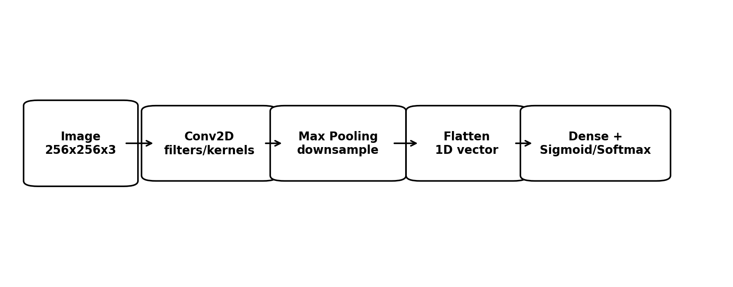
Figure: CNN image classification pipeline

9.1 CNN Components
Component | Purpose | Example
Convolution Layer | Filters/kernels image par slide kar ke features detect karte hain. | Edges, shapes, texture
Kernel/Filter | Small matrix jo image region se convolve hoti hai. | 3x3 filter
Max Pooling | Feature map size reduce karta hai aur strongest feature keep karta hai. | 2x2 pooling
Flatten | 2D/3D feature maps ko 1D vector banata hai. | Dense layer input
Dense Layer | Final classification/prediction. | Cat vs dog
Dropout | Overfitting reduce karta hai. | Dropout(0.5)

9.2 CNN Intuition
Early convolution layers basic edges detect kar sakti hain. Deeper layers complex patterns, object parts aur final object-level features learn kar sakti hain. Pooling computation reduce karta hai aur small position changes ke against robustness deta hai.

9.3 Image Classification Code Skeleton

import tensorflow as tf
from tensorflow.keras import layers, models
from tensorflow.keras.preprocessing.image import ImageDataGenerator

train_datagen = ImageDataGenerator(rescale=1./255, rotation_range=20, zoom_range=0.2,
horizontal_flip=True, validation_split=0.2)
test_datagen = ImageDataGenerator(rescale=1./255)
training_set = train_datagen.flow_from_directory('Train', target_size=(256,256), batch_size=32,
class_mode='binary', subset='training')
validation_set = train_datagen.flow_from_directory('Train', target_size=(256,256), batch_size=32,
class_mode='binary', subset='validation')
test_set = test_datagen.flow_from_directory('Test', target_size=(256,256), batch_size=32,
class_mode='binary')
model = models.Sequential([
layers.Conv2D(32, (3,3), activation='relu', input_shape=(256,256,3)),
layers.MaxPooling2D(2,2),
layers.Conv2D(64, (3,3), activation='relu'),
layers.MaxPooling2D(2,2),
layers.Conv2D(128, (3,3), activation='relu'),
layers.MaxPooling2D(2,2),
layers.Flatten(),
layers.Dense(128, activation='relu'),
layers.Dropout(0.5),
layers.Dense(1, activation='sigmoid')
])
model.compile(optimizer='adam', loss='binary_crossentropy', metrics=['accuracy'])
model.fit(training_set, epochs=10, validation_data=validation_set)
print(model.evaluate(test_set))

9.4 Common Practical Issues
Issue | Reason | Fix
Low accuracy | Small/poor data, wrong labels, too few epochs | More data, clean labels, tune model
Overfitting | Train accuracy high, val low | Dropout, augmentation, early stopping
Shape error | Input image size/channel mismatch | Match input_shape and target_size
Wrong class_mode | Binary vs multi-class mismatch | binary for 2 classes, categorical for many
Slow training | Large images/model | Reduce image size, use GPU

9.5 Tricky Questions with Answers
Question | Answer
Flatten ka role kya hai? | Pooled feature maps ko 1D vector mein convert karna for Dense layer.
CNN filters kya detect karte hain? | Edges, shapes, textures, objects/features.
Max pooling feature map ko kya karta hai? | Spatial size reduce karta hai and strongest activation keep karta hai.
Data augmentation kyun use hoti hai? | Overfitting reduce and training variety increase.
Binary output mein final activation kya? | Sigmoid. Multi-class mein softmax.

9.6 Exam Tips
- CNN answer mein sequence likho: Conv -> ReLU -> Pool -> Flatten -> Dense -> Output.
- Kernel size, filters aur pooling ka role short example ke saath likho.
- Image input shape (height,width,channels) mention karo.

10. RNN, LSTM and GRU
RNN sequence data ke liye use hota hai, jaise text, speech, time-series. RNN mein loop/memory hoti hai, yani previous information next step ko pass hoti hai. LSTM aur GRU standard RNN ke vanishing gradient/memory issues ko improve karte hain.
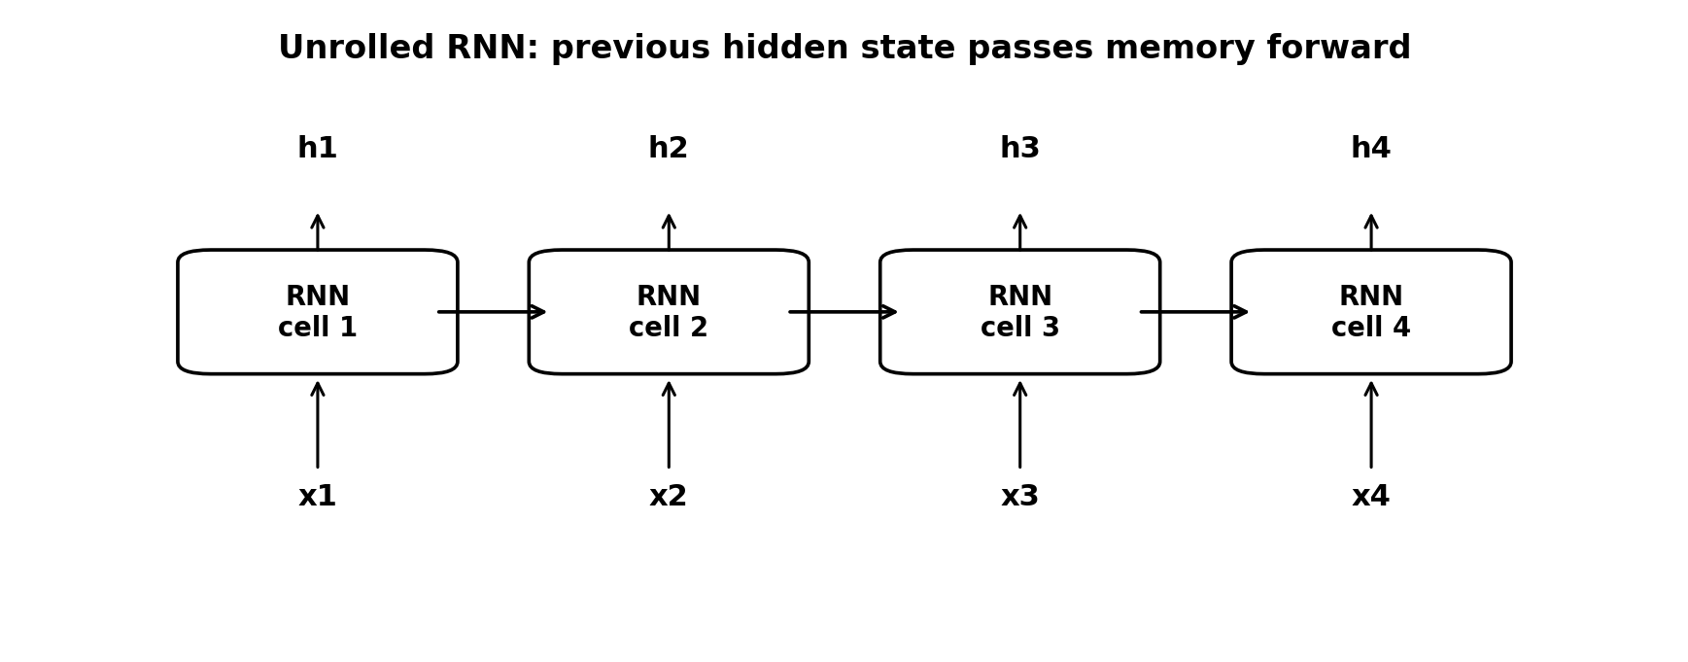
Figure: Unrolled RNN for sequence input

10.1 Sequence Model Types
Type | Input | Output | Example
Vector to Sequence | Fixed vector | Sequence | Weather values -> sentence
Sequence to Vector | Sequence | Fixed vector/class | Movie review -> sentiment
Sequence to Sequence | Sequence | Sequence | Machine translation, summarization

10.2 RNN Problem and LSTM Solution
Classical RNN slow train ho sakta hai aur long sequences mein vanishing gradient problem hoti hai. LSTM cell state maintain karta hai aur gates ke through decide karta hai kya forget, kya add aur kya output karna hai. Is se long-term dependencies better learn hoti hain.
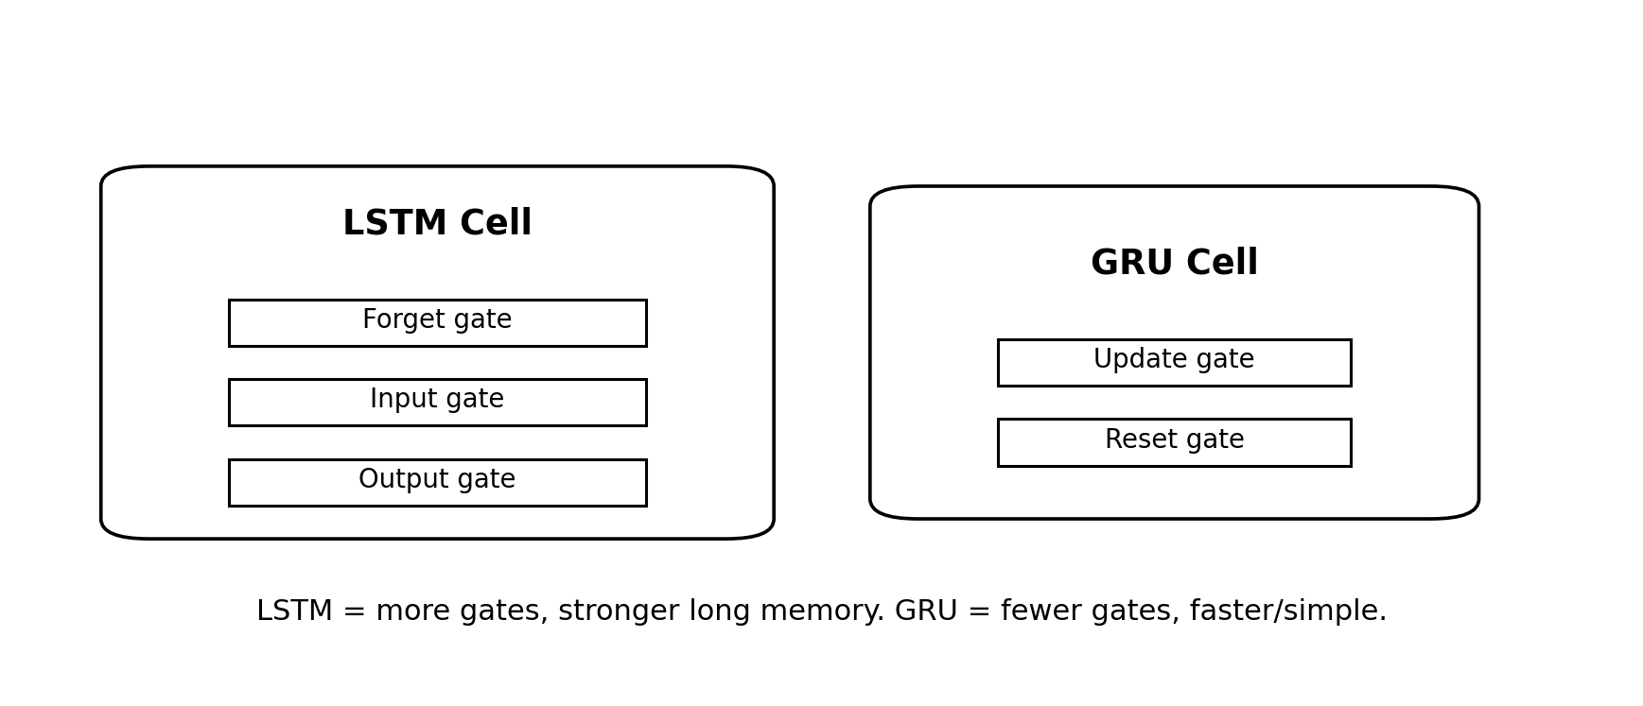
Figure: LSTM vs GRU gates

10.3 LSTM vs GRU
Point | LSTM | GRU
Gates | Forget, input, output gates | Update and reset gates
Memory | Separate cell state | Simpler hidden-state based memory
Complexity | More parameters, slower | Fewer parameters, often faster
Use | Long dependencies, complex tasks | Text classification, sequence modeling, faster training

10.4 Text Sequence Code Skeleton

import numpy as np
from tensorflow.keras.preprocessing.text import Tokenizer
from tensorflow.keras.preprocessing.sequence import pad_sequences
from tensorflow.keras.models import Sequential
from tensorflow.keras.layers import Embedding, SimpleRNN, LSTM, GRU, Dense

sentences = ['I love this movie', 'The film was boring']
labels = np.array([1, 0])
tokenizer = Tokenizer(num_words=10000)
tokenizer.fit_on_texts(sentences)
sequences = tokenizer.texts_to_sequences(sentences)
max_length = max(len(seq) for seq in sequences)
X = pad_sequences(sequences, maxlen=max_length, padding='post', truncating='post')
model = Sequential([
Embedding(10000, 16, input_length=max_length),
SimpleRNN(32, return_sequences=True),
LSTM(32, return_sequences=True),
GRU(32, return_sequences=False),
Dense(1, activation='sigmoid')
])
model.compile(loss='binary_crossentropy', optimizer='adam', metrics=['accuracy'])
model.fit(X, labels, epochs=10, validation_split=0.2)

10.5 Tokenizer, Padding, Embedding
Term | Explanation
Tokenizer | Words ko numeric tokens/indexes mein convert karta hai.
texts_to_sequences | Sentences ko token lists mein convert karta hai.
pad_sequences | Different length sentences ko same length banata hai.
Embedding | Word indexes ko dense vectors mein map karta hai. Similar words vectors mein close ho sakte hain.
return_sequences=True | Next recurrent layer ko full sequence output dene ke liye.

10.6 Tricky Questions with Answers
Question | Answer
RNN ka main benefit? | Previous information/memory preserve kar sakta hai.
Vanishing gradient kis mein common issue hai? | Classical RNNs in long sequences.
LSTM mein gates ka role? | Information forget/add/output control karna.
GRU LSTM se simple kyun? | Fewer gates: update and reset.
return_sequences=False ka effect? | Only final output return hota hai, not full sequence.

10.7 Exam Tips
- RNN answer mein loop/memory word zaroor use karo.
- LSTM long-term dependencies aur vanishing gradient solution ke sath explain karo.
- GRU ko simpler/faster LSTM alternative likho.

11. Transformers and Hugging Face NLP Tasks
Transformer deep learning model hai jo self-attention use karta hai. RNN sequence ko word by word process karta hai, lekin Transformer complete sequence ko parallel process kar sakta hai. Isi wajah se large NLP datasets par training efficient hoti hai.
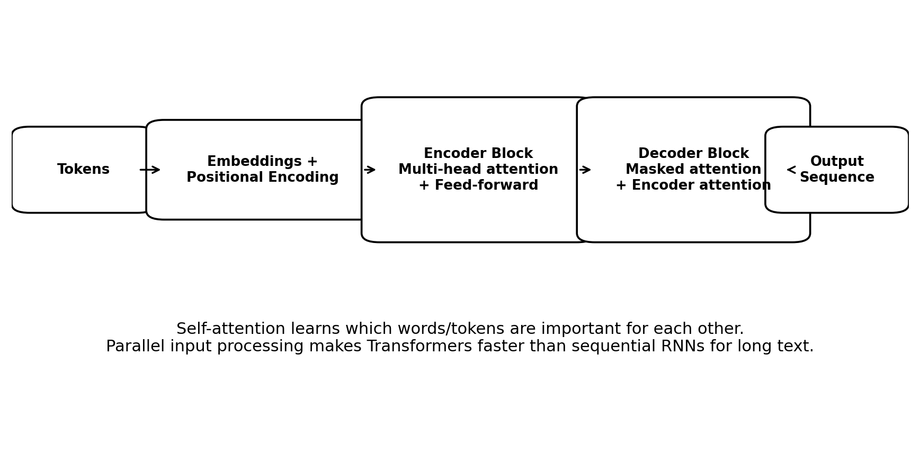
Figure: Transformer encoder-decoder workflow

11.1 Why Transformers?
RNN/LSTM issue | Transformer solution
Sequential processing: words one by one | Parallel processing: complete sentence at once
Long dependency difficult | Self-attention long-range relationships capture karta hai
GPU parallelism limited | Parallel matrix operations GPUs par efficient
Hidden state bottleneck | Attention har token ko relevant tokens se relate karta hai

11.2 Core Concepts
Concept | Easy explanation
Token | Sentence ka small unit, e.g., word/subword.
Embedding | Token ko numeric vector mein convert karna.
Embedding space | Vector space jahan similar meanings closer ho sakte hain.
Positional encoding | Transformer ko word order batata hai because no recurrence/time step.
Self-attention | Har word decide karta hai sentence ke dusre words kitne relevant hain.
Multi-head attention | Multiple attention views; model different relationships learn karta hai.
Feed-forward network | Attention output ko transform kar ke useful representation banata hai.
Encoder | Input sequence ko contextual representation mein encode karta hai.
Decoder | Output sequence generate karta hai, encoder context use kar sakta hai.

11.3 Encoder-Decoder Architecture
Encoder-decoder architecture sequence-to-sequence tasks ke liye useful hai, jaise translation, summarization aur question answering. Encoder input ka context banata hai; decoder output generate karta hai. Transformer decoder output generation ke liye crucial hota hai.

11.4 Hugging Face Pipeline Examples

from transformers import pipeline

# Sentiment analysis
sentiment = pipeline('sentiment-analysis')
print(sentiment('This movie was amazing!'))

# Named Entity Recognition
ner = pipeline('ner', aggregation_strategy='simple')
print(ner('Barack Obama visited Pakistan.'))

# Question Answering
qa = pipeline('question-answering')
print(qa(question='What is Transformer?', context='Transformer is a deep learning model using self-attention.'))

# Text summarization
summarizer = pipeline('summarization')
print(summarizer(long_text, max_length=60, min_length=20, do_sample=False))

# Text generation
generator = pipeline('text-generation')
print(generator('Artificial intelligence will', max_length=30))

11.5 Tasks Covered in Transformer Notebooks
Notebook/task | What it does | Typical pipeline/task type
Sentiment Analysis | Text positive/negative classify karta hai. | sentiment-analysis
Fake News Detection | News text ko fake/real class mein classify karna. | text-classification
NER | Names, locations, organizations detect karna. | ner
Question Answering | Context se answer extract karna. | question-answering
Text Summarization | Long text ko short summary banana. | summarization
Text Generation | Prompt se new text generate karna. | text-generation

11.6 Tricky Questions with Answers
Question | Answer
Transformer ko positional encoding kyun chahiye? | Because it processes tokens in parallel and has no natural time order like RNN.
Self-attention kya batata hai? | A token ka other tokens ke sath relevance/context.
Multi-head attention ka benefit? | Different heads different relationships/features capture karte hain.
Transformer RNN se faster kyun train ho sakta hai? | Parallel processing due to no strict sequential dependency.
Word2Vec/GloVe ka role? | Pretrained word embeddings/token vectors provide kar sakte hain.

11.7 Exam Tips
- Transformer answer mein 3 words zaroor: self-attention, positional encoding, parallel processing.
- Encoder input context banata hai; decoder output generate karta hai.
- RNN vs Transformer comparison MCQs mein common hota hai.

12. Speech-to-Text and Text-to-Speech
Speech-to-Text audio ko text mein convert karta hai. Text-to-Speech text ko spoken audio mein convert karta hai. Uploaded notebooks mein SpeechRecognition/pydub aur gTTS use hua hai.
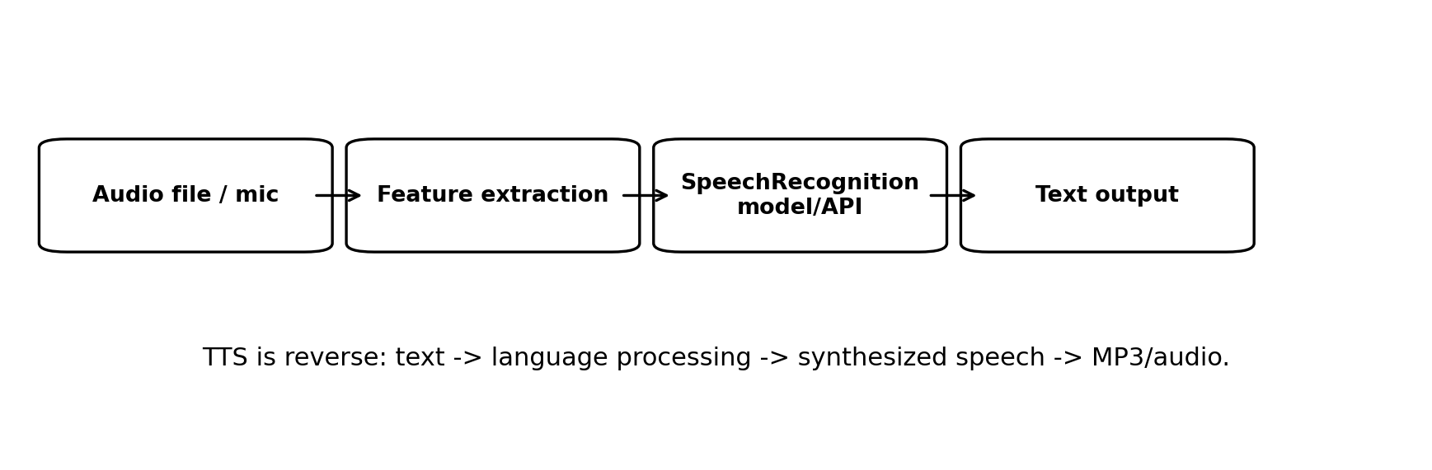
Figure: Speech-to-text and text-to-speech workflow

12.1 Speech-to-Text Code Skeleton

# pip install SpeechRecognition pydub
import speech_recognition as sr

recognizer = sr.Recognizer()
with sr.AudioFile('audio.wav') as source:
audio = recognizer.record(source)
text = recognizer.recognize_google(audio)
print(text)

12.2 Text-to-Speech Code Skeleton

# pip install gTTS
from gtts import gTTS

text = 'Hello, this is text to speech.'
tts = gTTS(text=text, lang='en')
tts.save('output.mp3')

12.3 Practical Notes
- Audio file format compatible hona chahiye; pydub conversion mein help kar sakta hai.
- Internet-based recognizers/gTTS ke liye internet required ho sakta hai.
- Noise audio recognition accuracy reduce kar sakti hai.
- Language code sahi dena important hai.

12.4 Tricky Questions with Answers
Question | Answer
STT ka input kya hai? | Audio/speech.
TTS ka output kya hai? | Audio/speech file or spoken sound.
Noisy audio ka effect? | Recognition accuracy decrease.
gTTS kis kaam ke liye? | Text ko speech/audio mein convert karna.
SpeechRecognition library ka role? | Audio se text recognize karna.

13. Flask Assignment and Project Preparation
Assignments mein Flask web application required hai jo CSV upload kare aur ML tasks perform kare: Linear Regression, K-Means, DBSCAN. Extension/project mein front-end + back-end pages aur multiple services/models included hain.

13.1 Assignment 3 Requirements
- CSV file upload karni hai.
- Data preprocessing aur visualization include karni hai.
- Linear Regression numerical prediction/modeling perform karna hai.
- K-Means clustering perform karna hai.
- DBSCAN density-based clustering perform karna hai.
- Model results user ko web app mein show karne hain.

13.2 Assignment 4 / Project Requirements
- Flask app mein main page hona chahiye jahan services ke links hon.
- Front-end aur back-end dono complete hon.
- DBSCAN page: user input/data se clustering and output visualization.
- K-Means page: clustering result, clusters/centroids display.
- Linear Regression page: model train/predict output.
- Clean UI, routes, templates, static files, result pages and error handling.

13.3 Suggested Flask Folder Structure

project_folder/
app.py
requirements.txt
templates/
index.html
upload.html
linear_regression.html
kmeans.html
dbscan.html
result.html
static/
style.css
plots/
uploads/

13.4 Flask Route Skeleton

from flask import Flask, render_template, request
import pandas as pd

app = Flask(__name__)

@app.route('/')
def index():
return render_template('index.html')

@app.route('/upload', methods=['GET', 'POST'])
def upload():
if request.method == 'POST':
file = request.files['csv_file']
df = pd.read_csv(file)
return render_template('result.html', tables=[df.head().to_html(classes='table')])
return render_template('upload.html')

if __name__ == '__main__':
app.run(debug=True)

13.5 Project Exam/Viva Tips
- Explain frontend and backend separately: templates/static are frontend; app.py/model logic backend.
- CSV validation mention karo: missing file, invalid columns, null values.
- Visualization ke liye matplotlib/seaborn/plotly mention kar sakte ho.
- Regression output numeric prediction; K-Means/DBSCAN output cluster labels.
- DBSCAN mein -1 label noise/outlier explain karo.

14. High-Yield Revision Tables

14.1 Algorithms at a Glance
Algorithm | Learning type | Main input | Main output | Best for
Linear Regression | Supervised | X features + numeric Y | Predicted numeric value | Continuous prediction
Decision Tree ID3 | Supervised | Labeled dataset | Class decision tree | Classification with rules
K-Means | Unsupervised | K and data points | Clusters + centroids | Compact/spherical clusters
DBSCAN | Unsupervised | epsilon, minPts | Clusters + noise | Density/arbitrary shape/outliers
Apriori | Unsupervised | Transactions + min support/conf | Frequent itemsets + rules | Market basket analysis
ANN | Supervised mostly | Features + labels | Prediction/class | Complex non-linear patterns
CNN | Deep learning | Images | Image class/prediction | Image classification
RNN/LSTM/GRU | Deep learning | Sequences | Sequence class/output | Text/time series/speech
Transformer | Deep learning | Token sequences | NLP/CV outputs | Attention-based NLP tasks

14.2 Common Confusions
Confusion | Correct understanding
Regression vs Classification | Regression predicts number; classification predicts class.
K-Means vs KNN | K-Means clustering unsupervised; KNN supervised classification/regression.
DBSCAN minPts | Central point is counted.
Support vs Confidence | Support is frequency of itemset; confidence is reliability of rule A->B.
Sigmoid vs Softmax | Sigmoid binary; softmax multi-class probabilities.
RNN vs Transformer | RNN sequential; Transformer parallel with self-attention.
LSTM vs GRU | LSTM more gates; GRU fewer gates and often faster.
Loss vs Metric | Loss optimized; metric reported.

14.3 Exam Answer Templates
Question type | Answer structure
Define algorithm | Definition -> key idea -> inputs -> output -> example.
Compare algorithms | Table with parameters, output, strengths, limitations.
Numerical | Formula -> substitution -> calculation -> final answer.
Code explanation | Libraries -> data loading -> preprocessing -> model -> train/evaluate -> output.
Viva answer | One-line meaning + real-world example + one limitation.

15. Mock Exam 1
Suggested time: 60 minutes. Pehle khud solve karo, phir answer key dekho.

15.1 MCQs
1. Which algorithm is used for market basket analysis?
- A. K-Means
- B. Apriori
- C. CNN
- D. RNN
2. In Linear Regression, dependent variable is usually:
- A. Categorical
- B. Continuous numeric
- C. Cluster label only
- D. Noise point
3. K-Means updates cluster centers using:
- A. Median only
- B. Mode only
- C. Average of points
- D. Entropy
4. DBSCAN identifies outliers as:
- A. Centroids
- B. Noise points
- C. Leaf nodes
- D. Kernels
5. ID3 selects root using maximum:
- A. Loss
- B. Confidence
- C. Information Gain
- D. Batch size
6. Sigmoid output is commonly used for:
- A. Binary classification
- B. K-Means centroid
- C. DBSCAN epsilon
- D. Association support
7. CNN is most commonly used for:
- A. Image classification
- B. Market basket only
- C. Entropy calculation
- D. CSV routing
8. RNNs are suitable for:
- A. Sequence data
- B. Only tabular data
- C. Only itemsets
- D. Only centroids
9. Transformer uses which key mechanism?
- A. Self-attention
- B. Support count
- C. Euclidean update
- D. Max entropy
10. In sklearn DBSCAN, label -1 means:
- A. Best cluster
- B. Noise/outlier
- C. Centroid
- D. Root node

15.2 Short Questions
1. Explain support, confidence and lift with formulas.
2. Write K-Means algorithm steps.
3. Why single perceptron cannot solve XOR?
4. Differentiate LSTM and GRU.
5. Explain positional encoding in Transformer.

15.3 Numerical/Practical Questions
1. For X={1,2,3,4}, Y={3,4,5,7}, calculate Linear Regression equation.
2. Given min support count=2 and total transactions=5, find min_support value.
3. For point (168,60), calculate distance from centroids (185,72) and (170,56).

15.4 Answer Key
MCQs: 1-B, 2-B, 3-C, 4-B, 5-C, 6-A, 7-A, 8-A, 9-A, 10-B
Short answers: use relevant sections 6.1, 3.4, 7.4, 10.3, 11.2. Numericals: Linear regression Y=1.3X+1.5; min_support=0.4; distances 20.80 and 4.48.

16. Mock Exam 2
Suggested time: 75 minutes. This paper is slightly more conceptual.

16.1 MCQs
1. Entropy zero means:
- A. Pure node
- B. Fully mixed node
- C. High loss
- D. Noise point
2. Apriori principle says if an itemset is infrequent then:
- A. Its supersets are also infrequent
- B. Its subsets are also infrequent
- C. It becomes centroid
- D. It is core point
3. Which layer converts feature maps into 1D vector?
- A. Conv2D
- B. Flatten
- C. MaxPooling only
- D. Embedding
4. Embedding layer converts words into:
- A. Images
- B. Dense vectors
- C. Centroids
- D. CSV files
5. Batch size refers to:
- A. Full passes over data
- B. Samples processed before one weight update
- C. Number of clusters
- D. Number of attributes
6. Softmax is commonly used for:
- A. Multi-class classification
- B. DBSCAN radius
- C. Linear regression slope
- D. Min support
7. DBSCAN requires:
- A. K only
- B. epsilon and minPts
- C. entropy and gain
- D. activation and loss
8. Decision Tree ID3 is:
- A. Greedy algorithm
- B. Purely neural network
- C. Speech synthesizer
- D. Transformer decoder
9. Dropout is used to reduce:
- A. Support
- B. Overfitting
- C. Epsilon
- D. Tokenization
10. Sequence-to-vector example is:
- A. Movie review to sentiment
- B. Translation sentence to sentence
- C. Weather vector to sentence
- D. Image resize only

16.2 Long Questions
1. Explain DBSCAN with core, border and noise points using epsilon/minPts.
2. Explain CNN architecture for binary image classification with code flow.
3. Explain Transformer encoder block and decoder block.
4. Discuss overfitting in deep learning and solutions.

16.3 Numerical/Rule Questions
1. Using Apriori dataset, calculate confidence for diaper -> beer.
2. Calculate entropy for a node with 9 Yes and 5 No approximately.
3. Perceptron: if expected=1 and actual=0, x1=1, a=0.2, old w1=-0.2, find new w1.

16.4 Answer Key
MCQs: 1-A, 2-A, 3-B, 4-B, 5-B, 6-A, 7-B, 8-A, 9-B, 10-A
Rules/numericals: diaper -> beer confidence = 0.75; entropy(9Y,5N) approx 0.940; new w1 = -0.2 + 0.2*1*1 = 0.

17. Mock Exam 3
Suggested time: 90 minutes. This paper mixes theory, numerical, code understanding and viva style.

17.1 MCQs
1. In Linear Regression Y = B(X)+A, B is:
- A. Intercept
- B. Slope/coefficient
- C. Entropy
- D. MinPts
2. For binary classification final Dense layer often uses:
- A. ReLU
- B. Sigmoid
- C. Linear only
- D. None
3. A core point in DBSCAN must have:
- A. Maximum IG
- B. At least minPts in eps-neighborhood
- C. Lowest confidence
- D. Highest epoch
4. Market basket rule A->B confidence denominator is:
- A. support(B)
- B. support(A)
- C. support(A union B) only
- D. lift(A)
5. RNN hidden state is used to carry:
- A. Cluster center
- B. Memory/context
- C. CSV file
- D. Entropy value
6. GRU has which gates?
- A. Forget/input/output
- B. Update/reset
- C. Kernel/pooling
- D. Support/confidence
7. Conv2D filters mainly detect:
- A. Edges/patterns
- B. CSV columns only
- C. Association rules
- D. Entropy branches
8. gTTS is used for:
- A. Text-to-speech
- B. Speech-to-text
- C. Clustering
- D. Regression
9. Information Gain equals:
- A. Child entropy - parent entropy
- B. Parent entropy - weighted child entropy
- C. Confidence/support(A)
- D. sqrt distance
10. Transformer processes sequence in parallel using:
- A. Centroid averaging
- B. Self-attention
- C. Support count
- D. Step function only

17.2 Explain/Compare
1. Compare K-Means and DBSCAN in a table.
2. Explain Keras compile(), fit(), evaluate().
3. Explain Tokenizer, pad_sequences and Embedding.
4. Explain why positional encoding is needed in Transformers.
5. Write Flask project flow for CSV upload and model result display.

17.3 Code Understanding

model = Sequential()
model.add(Dense(12, input_dim=8, activation='relu'))
model.add(Dense(32, activation='relu'))
model.add(Dense(1, activation='sigmoid'))
model.compile(optimizer='adam', loss='binary_crossentropy', metrics=['accuracy'])
model.fit(x_train, y_train, epochs=10, batch_size=10)
Questions: (1) Task type identify karo. (2) input_dim=8 ka matlab? (3) Final activation sigmoid kyun? (4) epochs and batch_size explain karo.

17.4 Answer Key
MCQs: 1-B, 2-B, 3-B, 4-B, 5-B, 6-B, 7-A, 8-A, 9-B, 10-B
Code answer: binary classification ANN; input_dim=8 means 8 input features; sigmoid probability output for binary class; epochs=10 means 10 full passes, batch_size=10 means 10 samples per weight update.

18. Last Night Cram Sheet
- Regression: continuous value, equation Y=B(X)+A, slope/intercept formulas.
- K-Means: choose K, distance, nearest centroid, update centroid, repeat.
- DBSCAN: epsilon radius, minPts, core/border/noise, -1 noise in sklearn.
- Decision Tree ID3: entropy + information gain, max IG root.
- Apriori: min support, confidence, lift, frequent itemsets, strong rules.
- Perceptron: Step(w*x+b), error=expected-actual, weight update wi=wi+a*xi*e, XOR limitation.
- Deep Learning/Keras: Sequential, Dense, activation, optimizer, loss, metrics, epochs, batch_size.
- CNN: Conv2D detects features, MaxPooling reduces size, Flatten to Dense, Dropout reduces overfitting.
- RNN/LSTM/GRU: sequence memory, LSTM long dependency, GRU fewer gates.
- Transformer: embeddings, positional encoding, self-attention, multi-head attention, encoder-decoder, parallel processing.
- STT/TTS: audio->text and text->audio, SpeechRecognition and gTTS.
- Flask: routes, templates, CSV upload, preprocessing, model run, result visualization.

18.1 Viva One-Liners
Topic | One-liner answer
Linear Regression | It predicts a continuous numeric value using a linear relation between X and Y.
K-Means | It groups unlabeled data into K clusters using nearest centroid distance.
DBSCAN | It forms clusters based on density and can detect noise/outliers.
ID3 | It builds a decision tree by selecting attributes with maximum information gain.
Apriori | It finds frequent itemsets and association rules using support and confidence.
ANN | It is a neural model inspired by biological neurons that learns from examples.
CNN | It uses convolution filters to detect image features for classification.
RNN | It handles sequential data by passing hidden state/memory across time steps.
LSTM | It is an RNN variant with gates to learn long-term dependencies.
GRU | It is a simpler gated RNN with reset and update gates.
Transformer | It uses self-attention and positional encoding to process sequences in parallel.

Final Advice
Preparation ka best method: definitions ratna nahi, har algorithm ka input -> processing -> output -> example yaad karo. Numericals mein formula aur steps clean likho. Code questions mein exact syntax se zyada pipeline samajhna important hota hai, lekin common imports aur functions yaad hone chahiye.

